**Experiment-10**

**Making Computer Lab in Cisco Packet Tracer.**

**Step1:** 1 Server, 1 Switch and 12 PCs

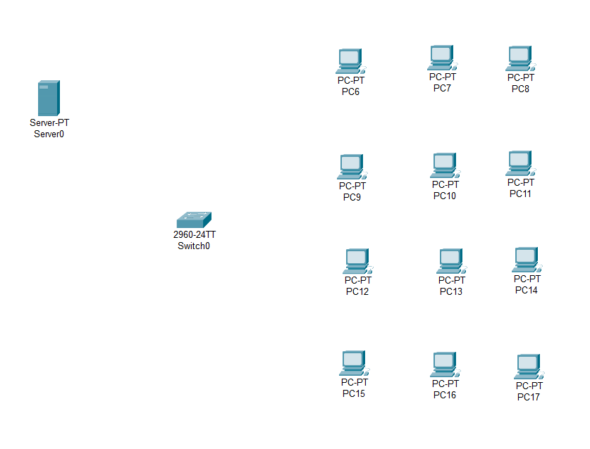

**Step2:** connect fast ethernets from Server to switch and switch to PCs

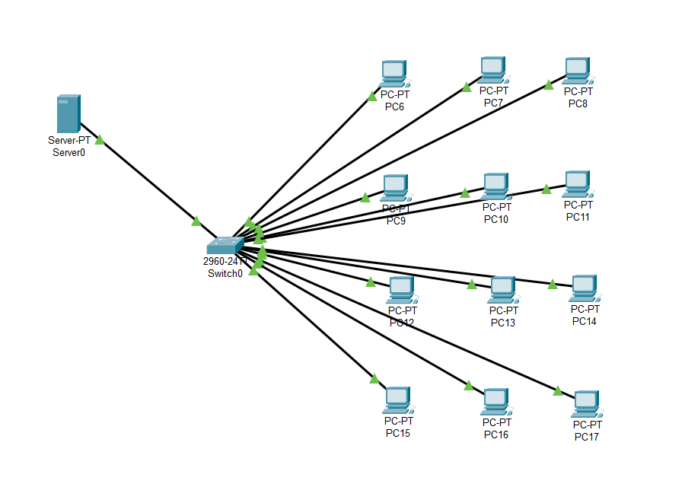

**Step3:** Assign IP address for each PCs

IP address for PC6:192.168.0.7

IP address for PC7: 192.168.0.8

IP address for PC8: 192.168.0.9

IP address for PC9: 192.168.0.10

IP address for PC10: 192.168.0.11

IP address for PC11: 192.168.0.12

IP address for PC12: 192.168.0.13

IP address for PC13: 192.168.0.14

IP address for PC14: 192.168.0.15

IP address for PC15: 192.168.0.16

IP address for PC16: 192.168.0.17

IP address for PC17: 192.168.0.18

**Step4:** allocate the message

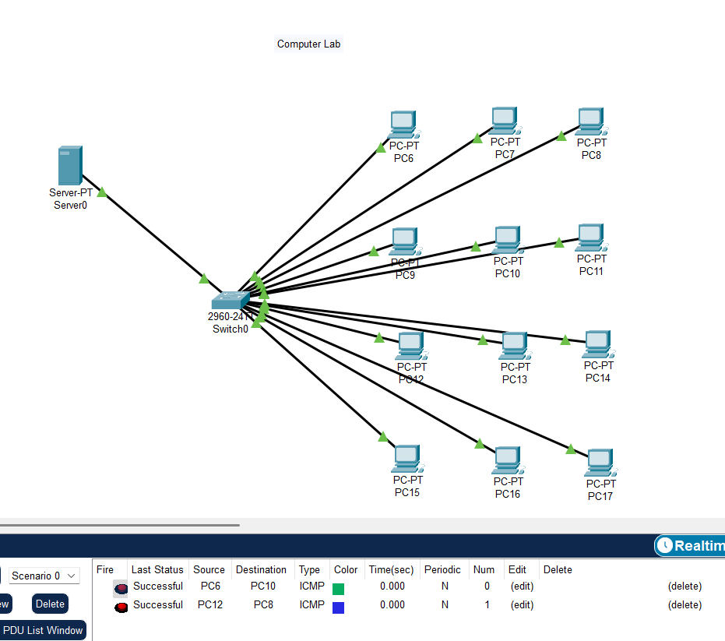

**Result:** message sent successfully from PC30-PC37